

Cooper Tire & Rubber Co.

International Certification System

System Documentation

Table of Contents

International Certification System 1

System Documentation 1

Table of Contents 2

1 Introduction 3

1.1 Application Architecture 3

1.2 Marketing Department 4

1.3 Quality Department 4

2 Applications details 4

2.1 Home Screen 4

2.1.1 Marketing 5

2.1.2 Quality 7

2.2 Certification Defaults 21

2.3 Reports 22

2.4 Archive 33

2.5 Approvals 34

3 Database 36

3.1 Database details 36

3.2 Database Object references (TNS Details) 36

4 External Interfaces 36

5 Background jobs 36

6 AD Groups 36

6.1 AD Group Member Entries for Individual User 36

7 Document history 37

# Introduction

In order to ship the finished tire to a country, it has to be tested according to their standards and has to be certified. If the tire is not certified then it cannot be shipped to the country. The International Certification System (ICS) is the system that has been defined to close a gap between the Marketing and the Quality groups by identifying products that require international certifications by country before the sale. The ICS is to be the system of record for the major certifications that Cooper Tire holds for compliance of shipping product to international locations and also maintains the validity period for the specific certificate which will vary based on the regulatory requirements. It allows the quality department to keep track of the certification.

## 

## Application Architecture

**International Certification System**

**Marketing**

**Certifications**

Add

Rename

Delete

Detach/Move

Family Maintenance

**Quality**

**Certification Defaults**

**Archive**

**Reports**

There are two main departments in the ICS application.

* + Marketing
  + Quality

## Marketing Department

* + Raise Request for Certification
  + The major certifications tracked through the system are:
    - E-mark (European Union)
    - I-mark (Brazil)
    - GSO (Gulf States Organization)
    - CCC (China) & NOM (Mexico)
    - The other certifications are India_Mark, Indonesia, South Korea, Taiwan, and Uruguay

## Quality Department

* + Work on Certification Request.
  + Prepare applications to submit Certification request to respective governments.
  + Update Certificate for any new product addition or changes.
  + Detach certificate from a product.
  + Move certificate from one product to another product.

# Applications details

## Home Screen

It contains two buttons namely Marketing and Quality.

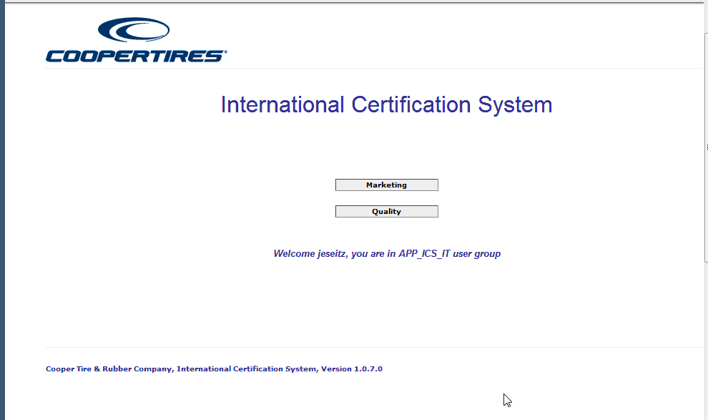

### Marketing

On the home page, click on Marketing button, it navigates to the page where the user can view the related certification requests for the Brand and Brand Line. Select a Brand and Brand Line and click on Search button. It displays the finished tire data in the grid.

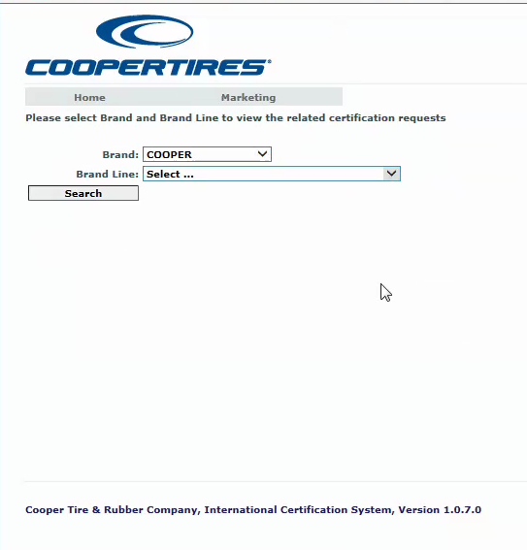

The table has the Material Number, Size of the tire and the check boxes under the different certifications.

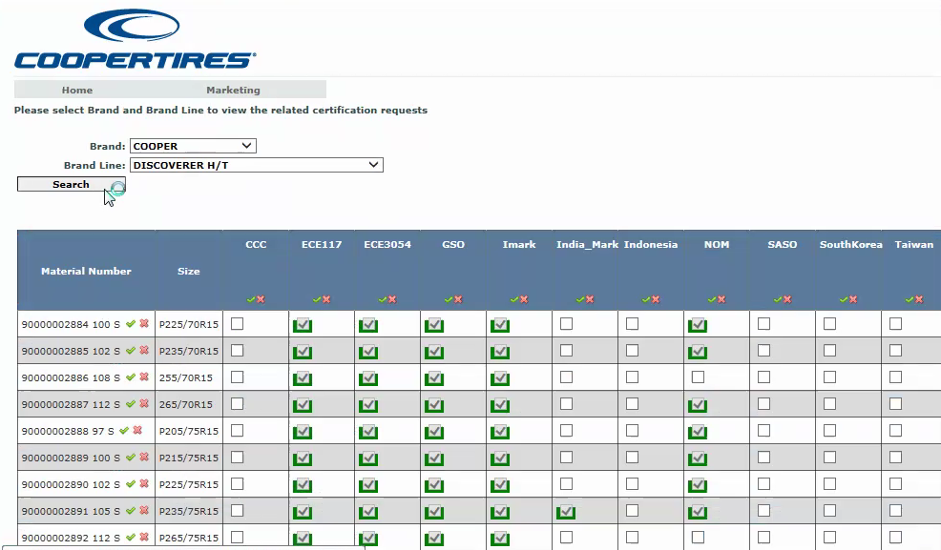

Hover on the Material Number, it displays the characteristics of the tire. Under a particular certification type, check the checkbox (eg. For a material number 90000002894, check Indonesia), the outline of the checkbox changes to red and click on Save button. The quality department receives an email from the marketing department, requesting that the particular tire has to be certified for the particular country.

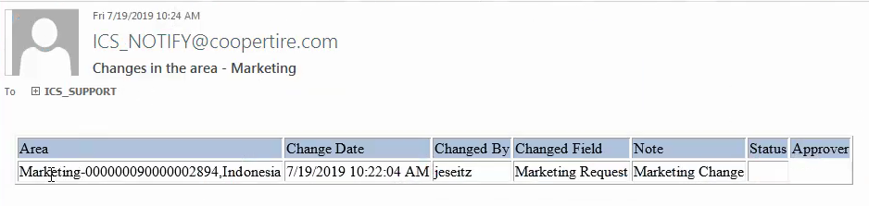

The tires that are requested, applied and approved are outlined by green colour. The yellow colour represent that the certification has been applied but pending approval.

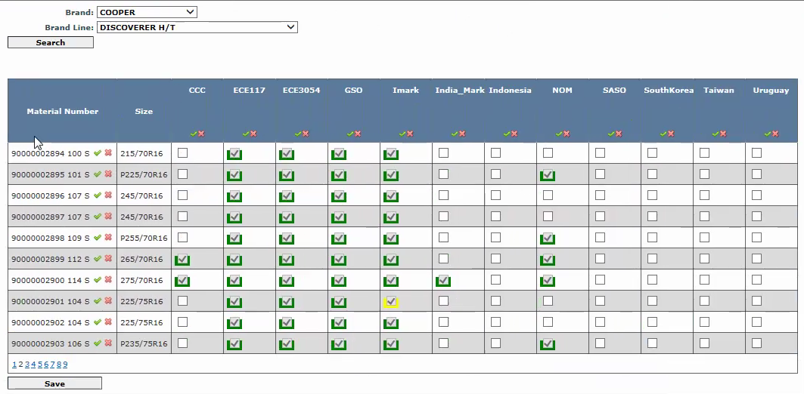



### Quality

On the home page, click on Quality, it navigates to Certification Search page.

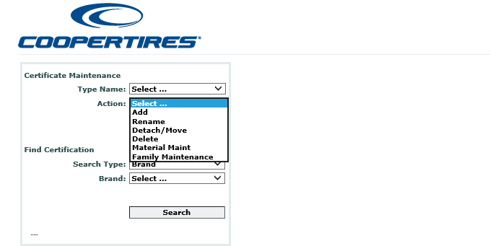

On this page, user can perform different maintenance operations.

* Add
* Rename
* Delete
* Detach/Move
* Material Maint
* Family Maintenance

#### Add certificate

The certificate has to be approved for a particular country. The process starts by adding a certificate to the SAP material number. User can select a Certificate from the Type Name (Indonesia) and select Add from the Action dropdown and click on Execute button.

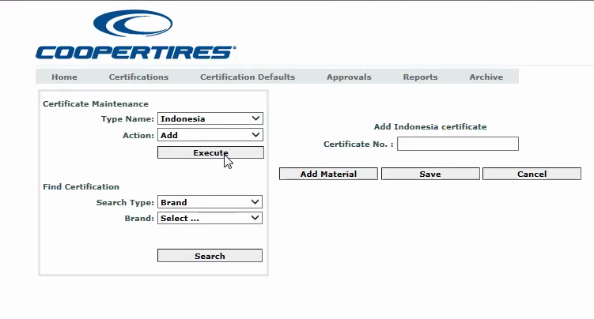

A section where the user can enter the Certificate No and add the material number to the certificate is displayed. Enter the Certificate No. (INDO4) and click on Add Material button, it displays the Material Number textbox. Enter the Material Number (90000002894) and click on Save button, the SAP Material Number should get associated to the Certificate.

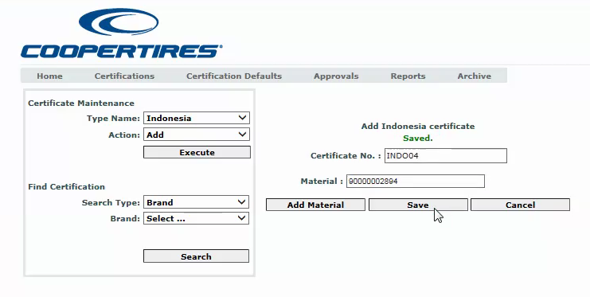

Multiple Material numbers can be added to a single certificate. In order to search for the certification that is added to the material number, select the Search Type (Material No.) and enter the material number and click on Search button. It displays the material number and the associated certifications in tree structure.

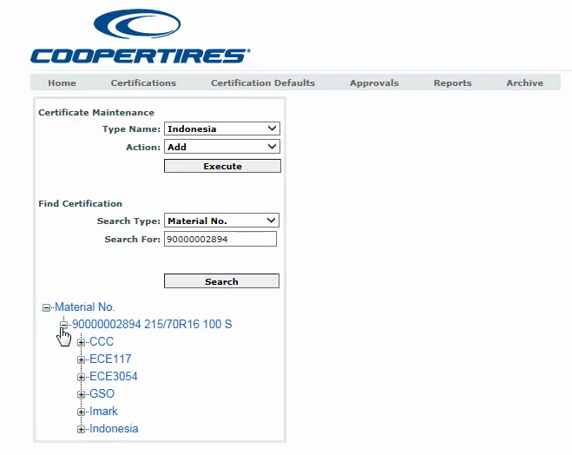

Expand the GSO certification, the certificate number (64921) is displayed in green colour as the certificate has been approved. Click on the certificate number it displays the certificate information. It displays two sections below one another. The top section displays the certificate information and the below section displays the information for the particular tire.

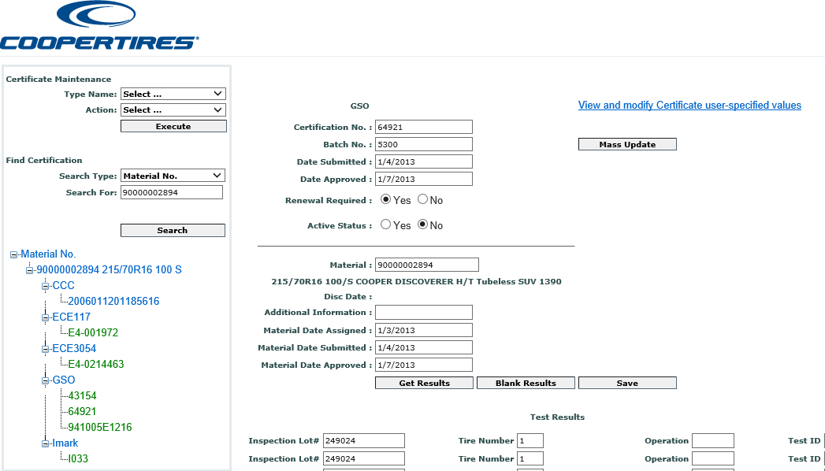

In the certificate information section, for some countries if the certificate is approved then the tires associated with the certificate are approved automatically. Enter the date in Material Date Submitted field and click on Save button. Search for the Material Number and verify the certificate under Indonesia, the certificate number (INDO4) is displayed in yellow.

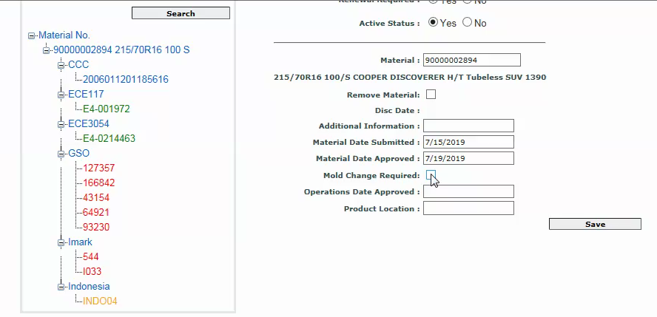

Enter the Material Date Approved date and click on save button. Search for the Material number and click on the material number tree, the certificate should be displayed in green as it has been approved.

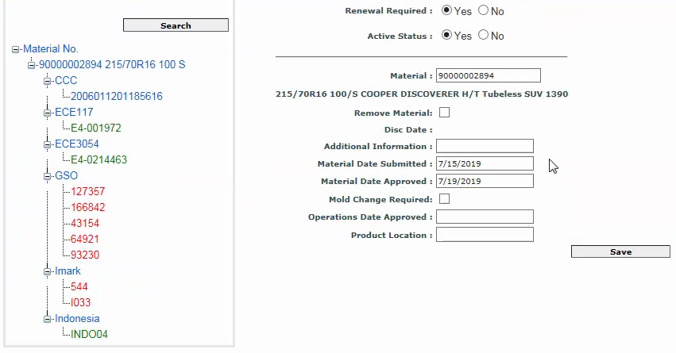

By Clicking on the Get results Button Test Results section will get displayed with the requested results.

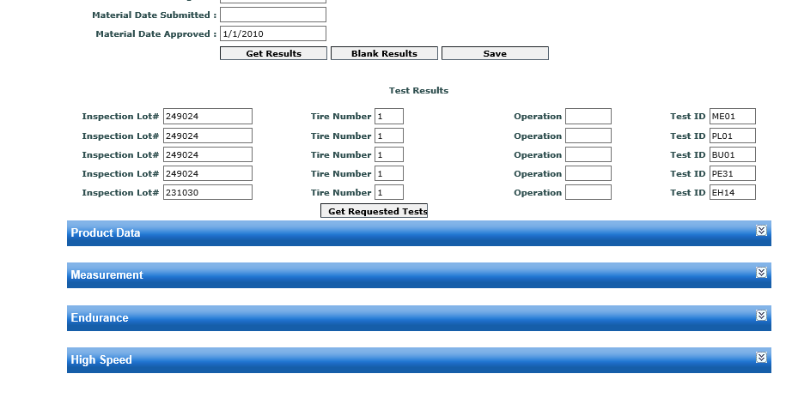

The certificate can be searched by certificate number.

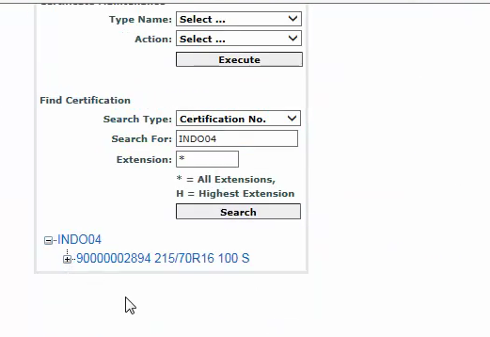

#### 2.1.2.2 Rename certificate

Select the certificate type and from the Action dropdown, select Rename and click on Execute button. Enter the old certificate and new certificate and click on Save button. The certificate gets renamed.

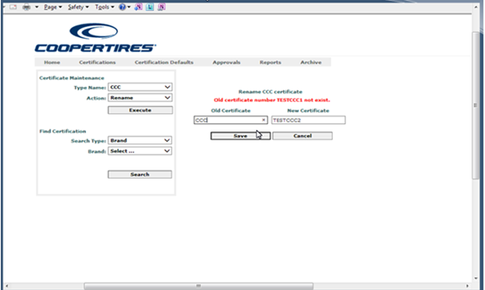

#### 2.1.2.3 Delete certificate

A certificate that is not being used can be deleted. Select the Certificate Type and from the Action dropdown, select Delete and click on Execute button. Enter the Certificate and click on Save button, the certificate gets deleted and the tires that are associate with the certificate get detached.

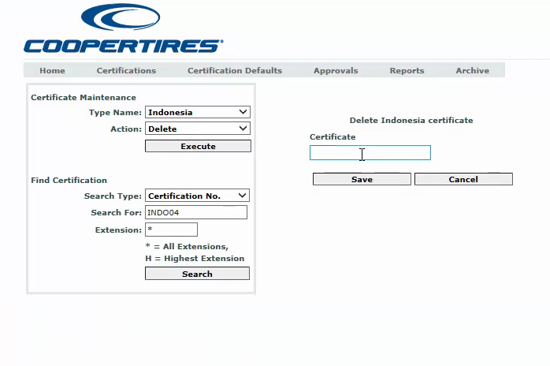

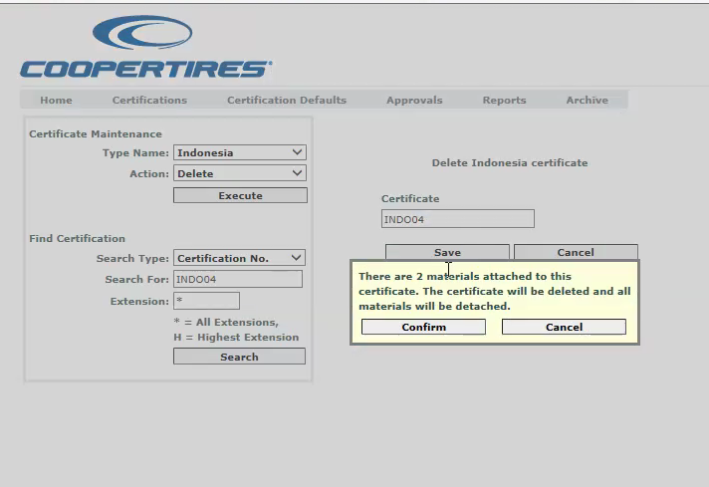

#### 2.1.2.4 Detach/Move certificate

The tire associated to a certificate can be detached from the certificate. Select the Certificate Type and from the Action dropdown, select Detach/Move and click on Execute button. Enter the Certificate and click on List button, the certificate is displayed with the associated material numbers in the grid. Click on Detach button in the grid, the tire gets detached from the certificate. Click on Move button and move the material number to a different certificate.

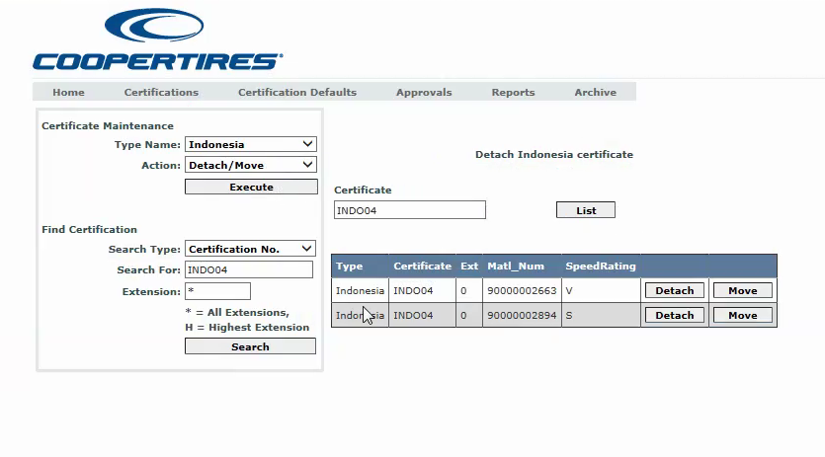

#### 2.1.2.5 Family Maintenance

Family is assigned to a tire based on different characteristics. Family codes are displayed in the grid and the characteristics can be added or deleted. Select the Type Name and Action form the drop down and click on Execute button. From the Family Maintenance Certificate select the certificate.

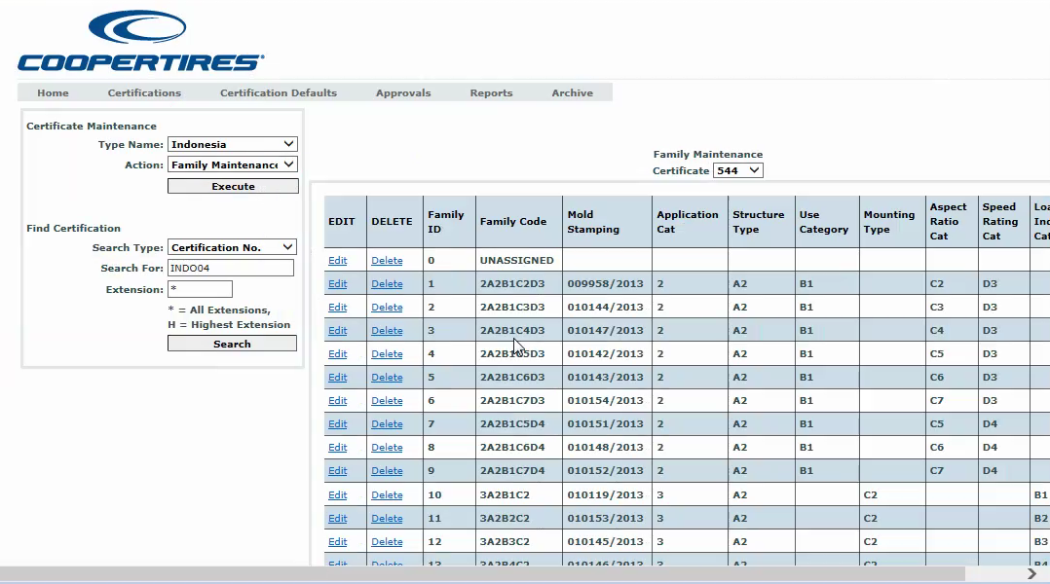

#### 2.1.2.6 Material Maint

**Delete**

Select the Type Name and Action from the drop down and select Delete and click on Execute button. After entering the Material Number and Speed Rating click on View. It will display the certificate and we can able to delete the certificate by clicking on delete in the grid.

## 

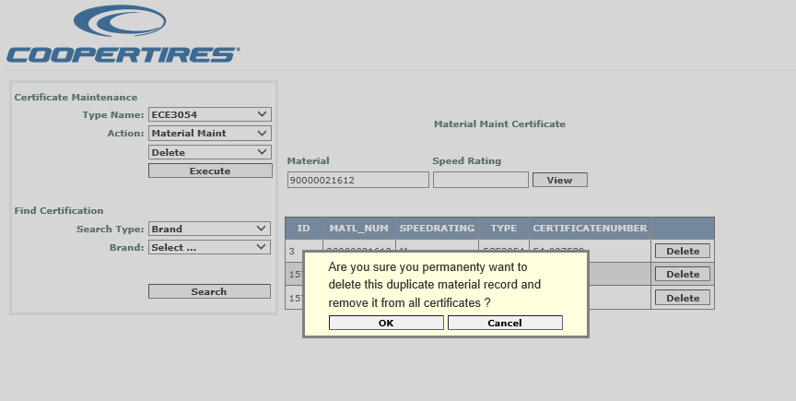

By clicking on Ok button the record from the grid will be deleted.

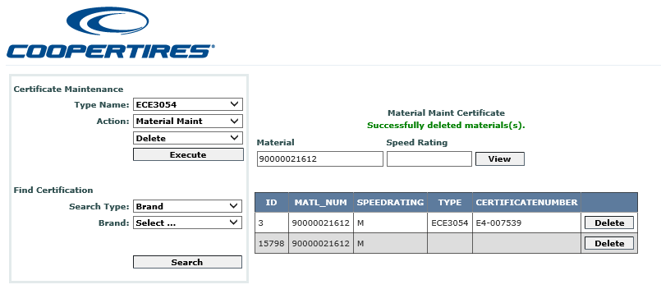

**Copy**

Select the Type Name and Action from the drop down and select Copy and click on Execute button. After entering the Material Number click on Copy. It will display the Popup and we can copy the Material By clicking on Ok in the Popup.

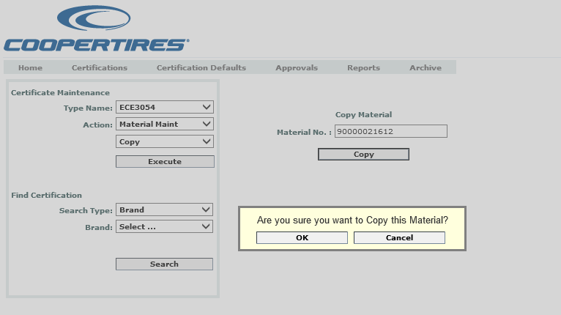

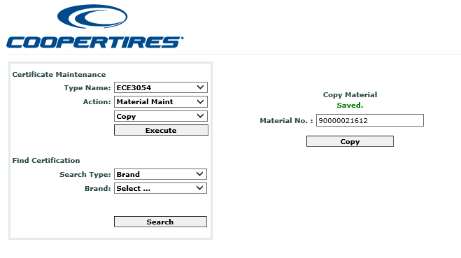

**Edit**

Select the Type Name and Action from the drop down and select Edit and click on Execute button. After entering the Material Number click on Show Details. It will display the details in the grid and we can click on Edit link in the grid.

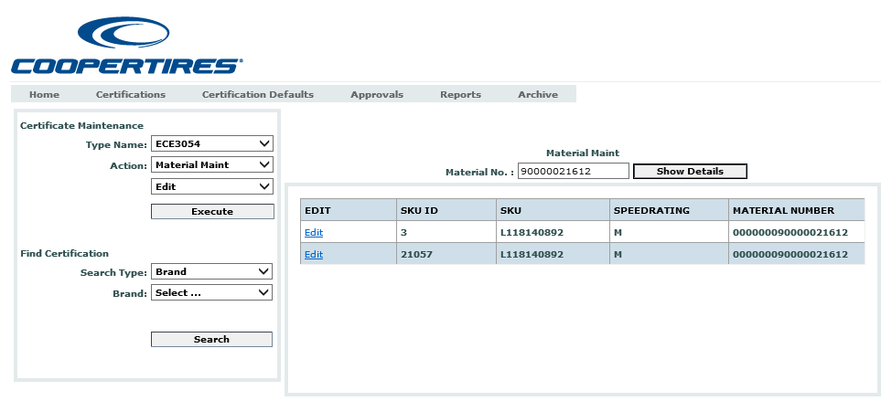

We can edit the options after clicking on Edit in the grid and click on Update to update the record.

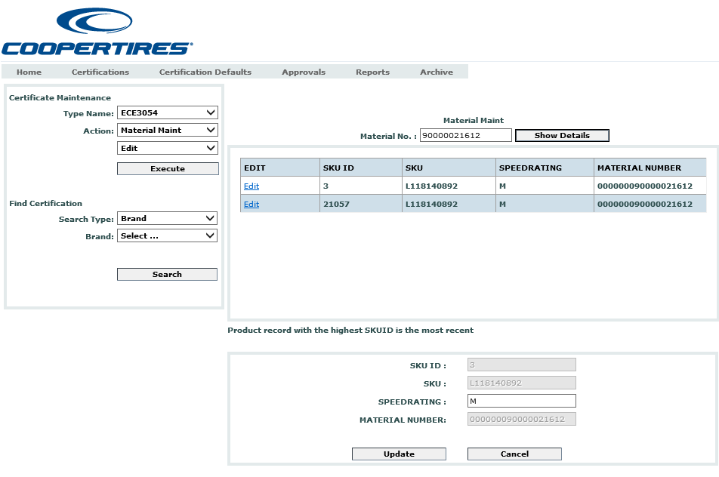

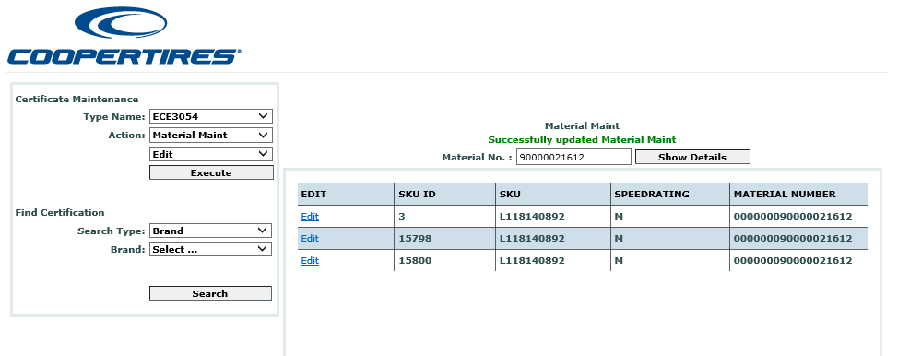

**Attach**

Select the Type Name and Action from the drop down and select Attach and click on Execute button. After entering the details like SKU ID, CERTIFICATE No, Extension No, Certification Type Id click on Attach. It will display the Popup and we can attach the Certificate By clicking on Ok in the Popup.

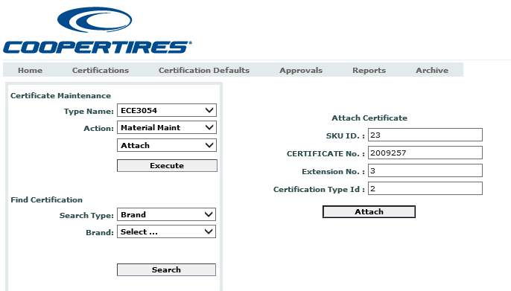

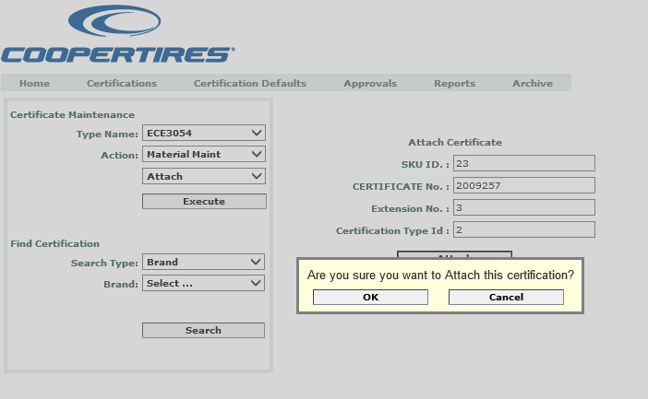

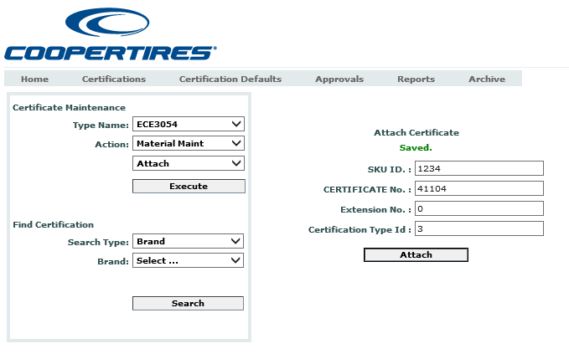

**Refresh Product Data**

Select the Type Name and Action from the drop down and select Refresh Product Data and click on Execute button. After entering the Material No click on Refresh. It will display the Popup and we can Refresh the Product By clicking on Ok in the Popup.

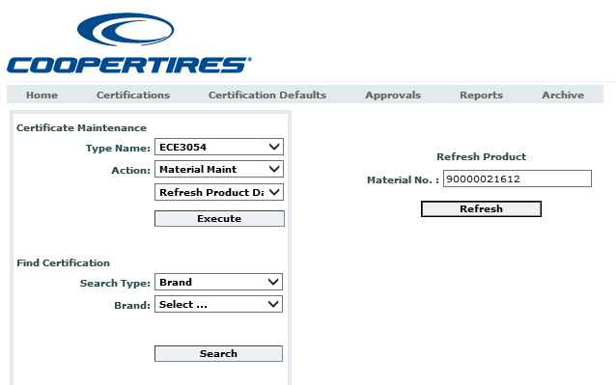

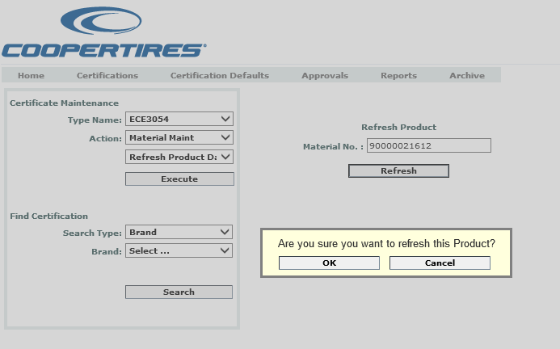

## Certification Defaults

For certain certification types, certain characteristics that apply to a certificate are created and a value is assigned to it. Select a certificate type, enter the default value and click on save button.

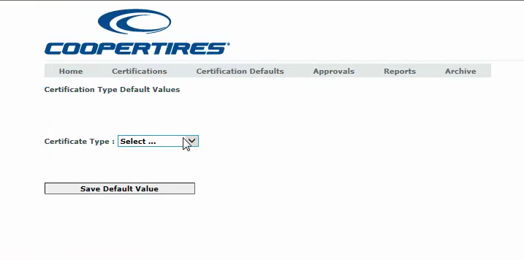

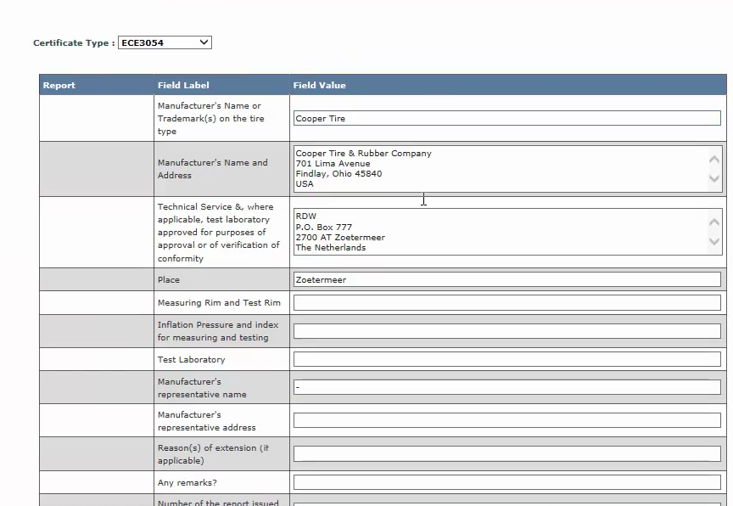

## Reports

Reports are submitted with the test results. Reports can be searched using different criteria.

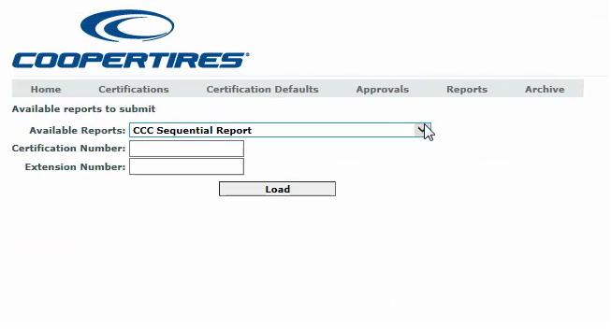

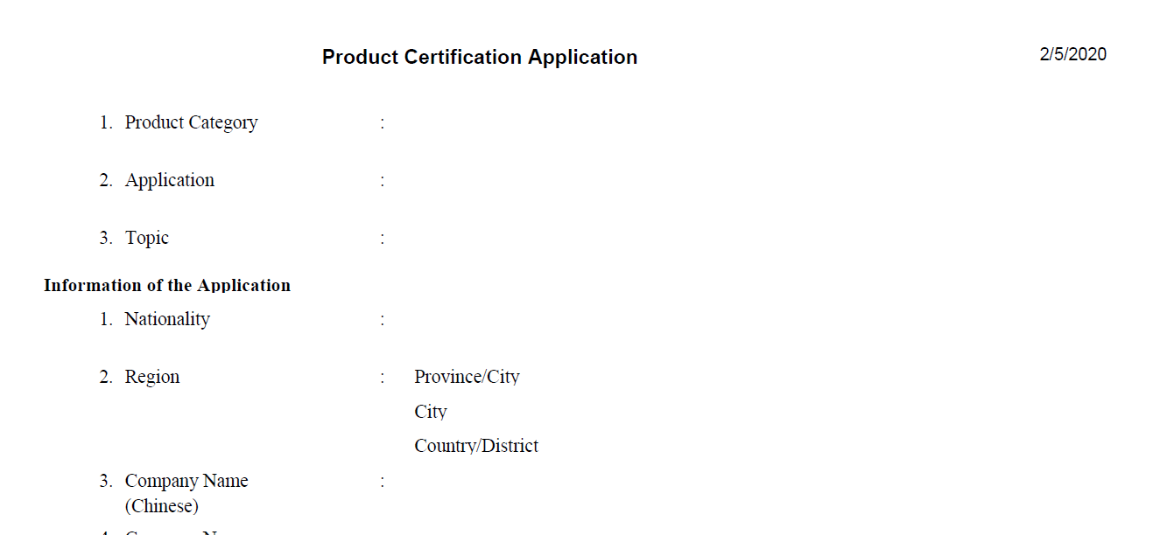

Select the report, enter the Certification Number and click on Load, it displays the report.

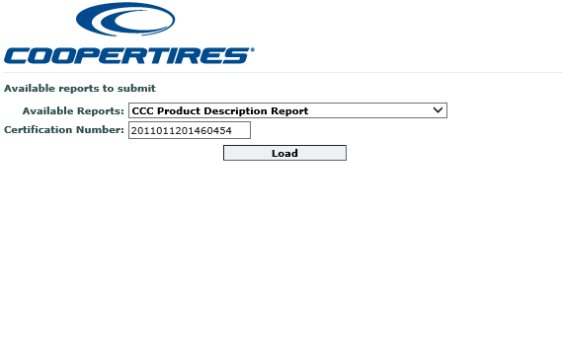

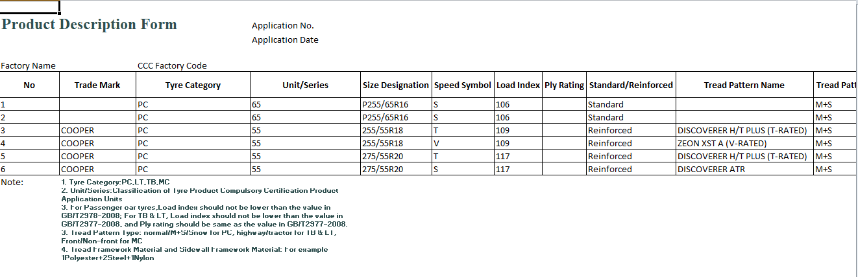

Select the report, enter the Material Number and click on Load, it displays the report.

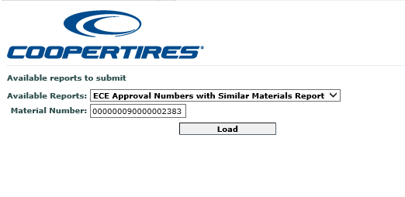

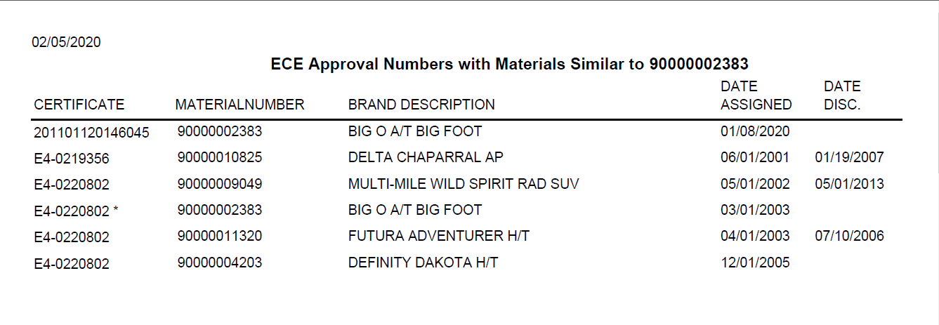

Select a report and click on Load button.

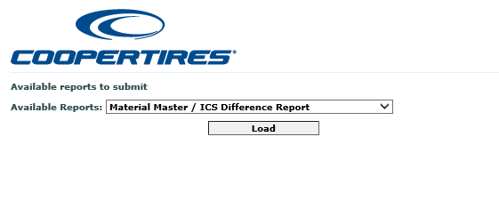

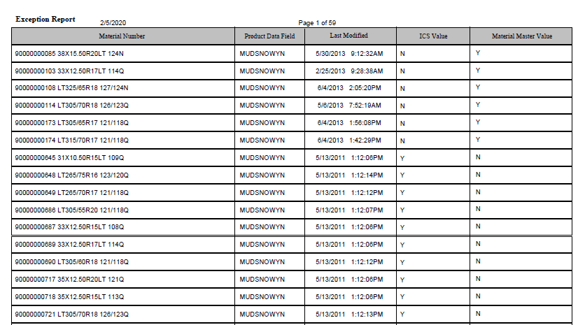

Select a report, enter the Certification Number, select the Certificate Type, and click on Load button.

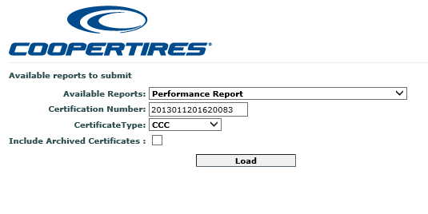

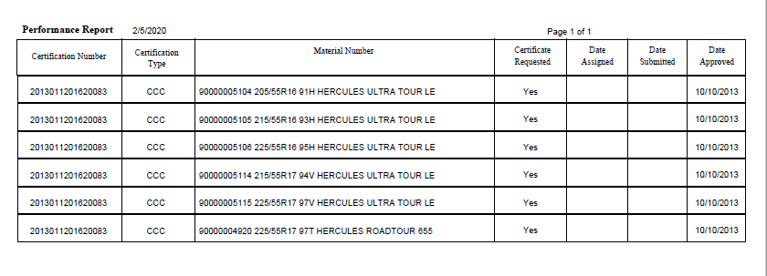

Select a report, enter the Certification Number and click on Load button.

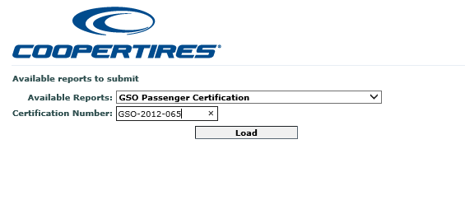

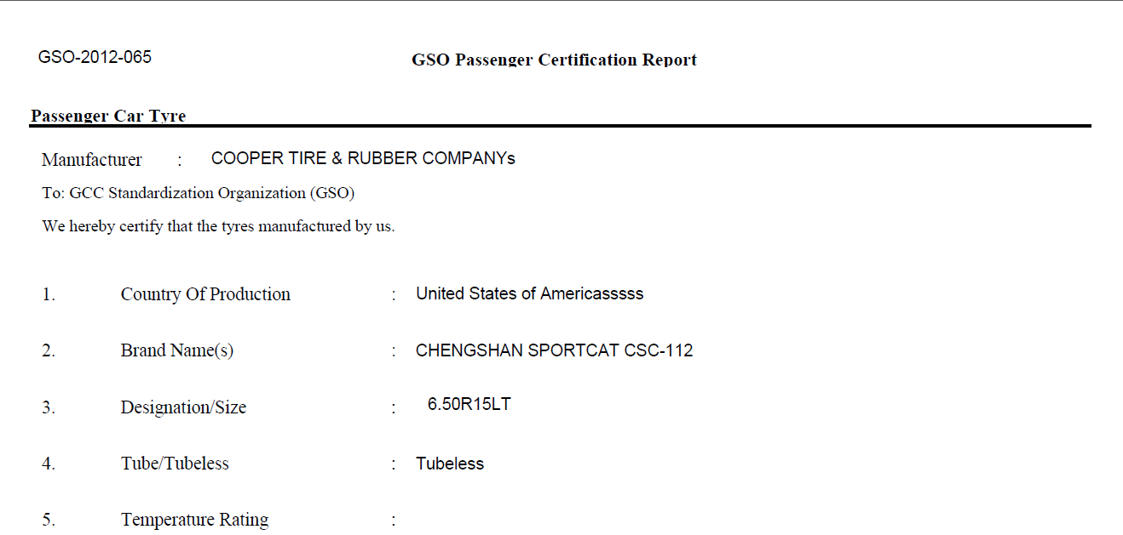

Select a report, enter the Certification Number and click on Load button.

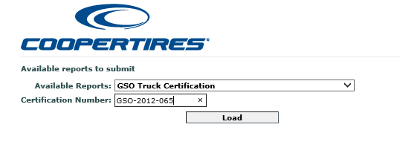

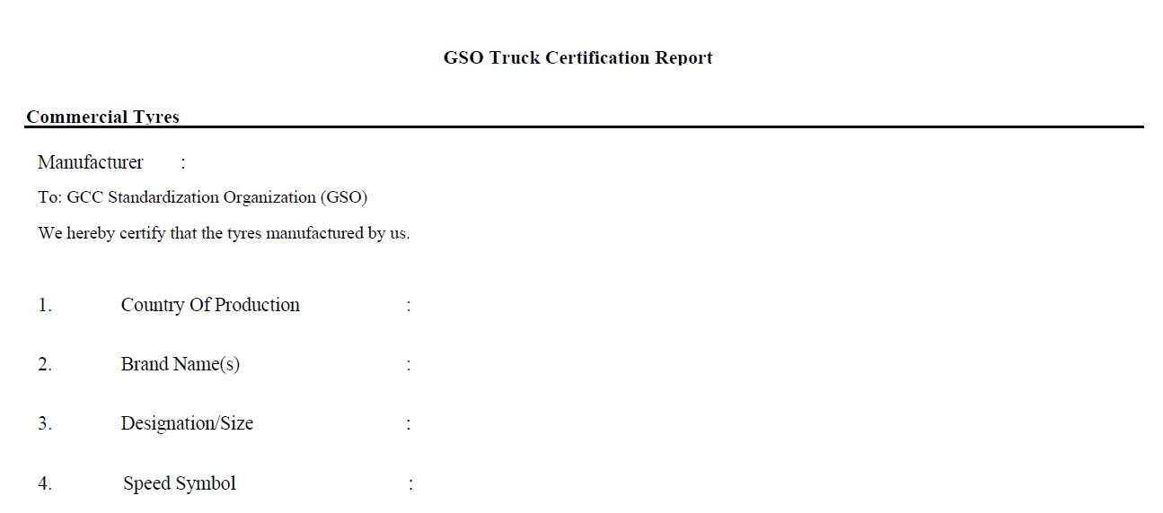

Select the report and click on Load button.

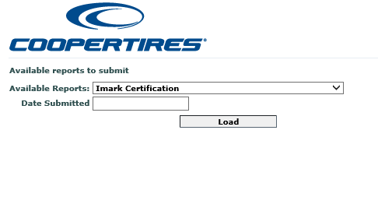

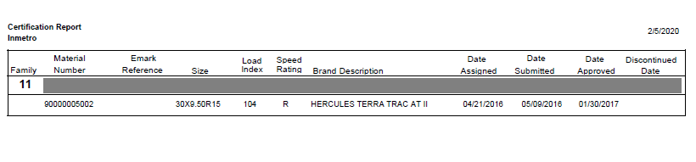

Select the report and click on Load button.

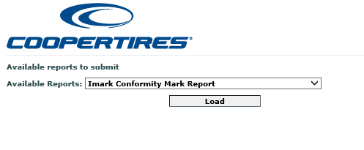

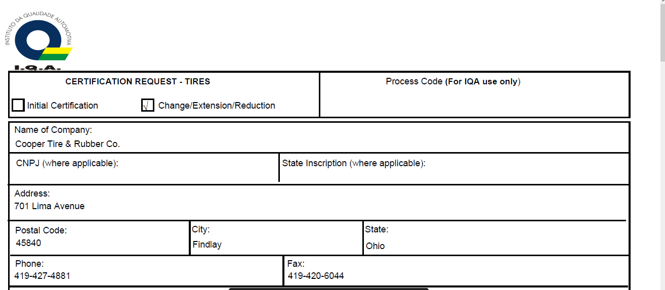

Select a report, enter the material Number and click on Load button.

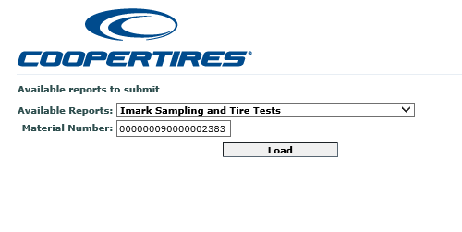

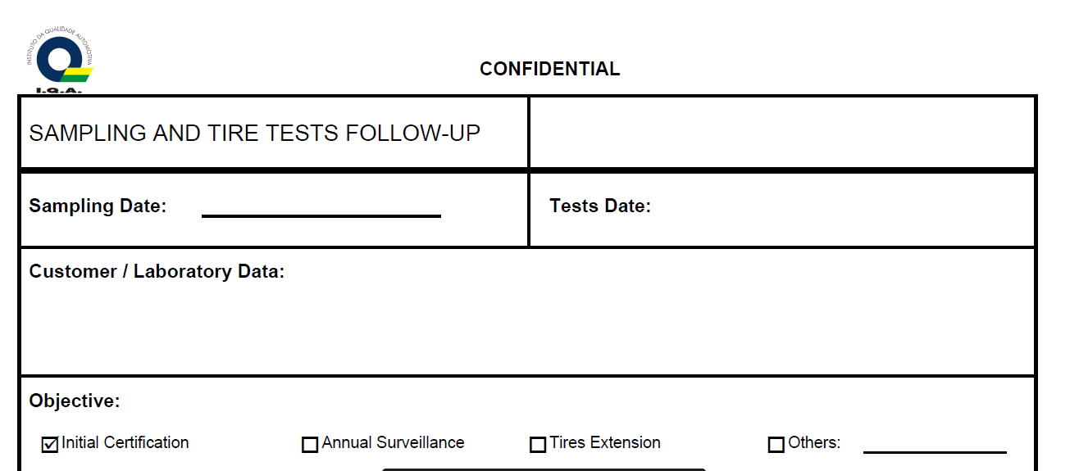

Select a report, and click on Load button.

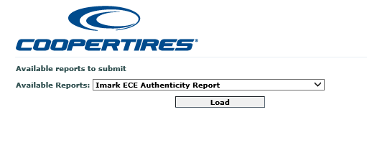

Select a report, enter the material Number and click on Load button.

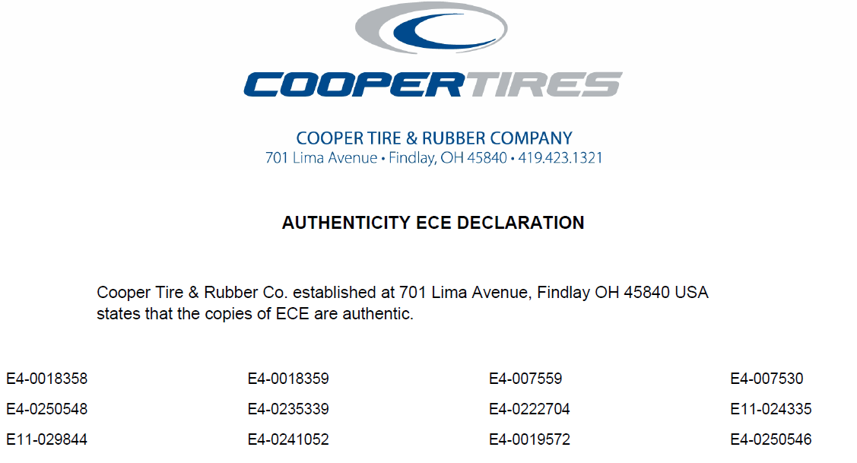

Select a report, enter the Certification Number and click on Load button.

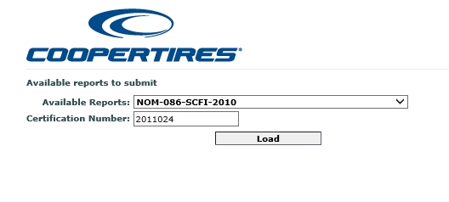

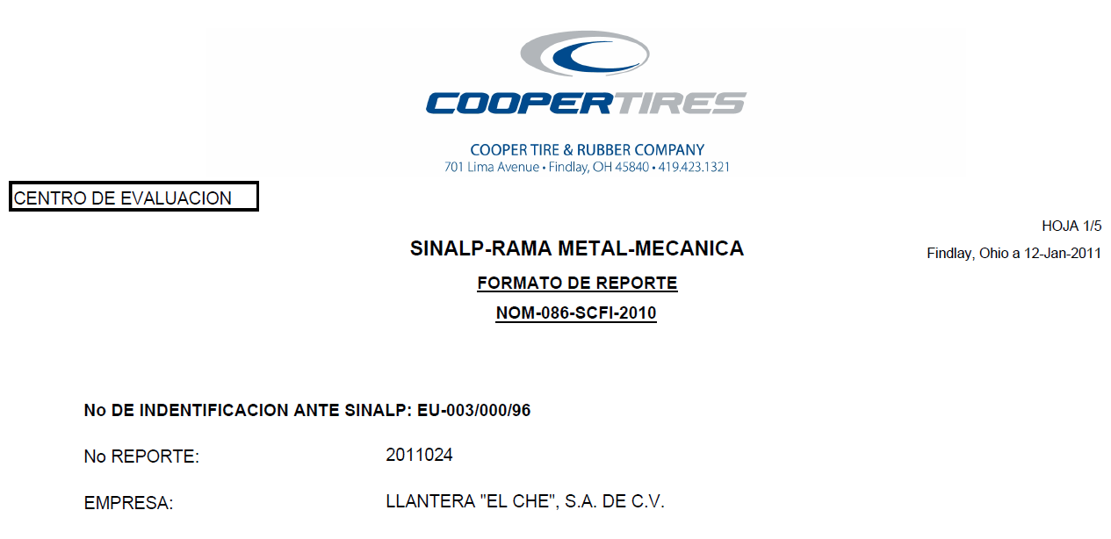

Select a report, enter the Certification Number and click on Load button.

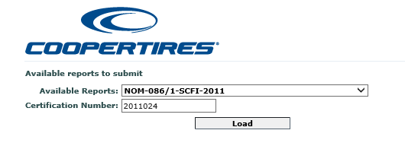

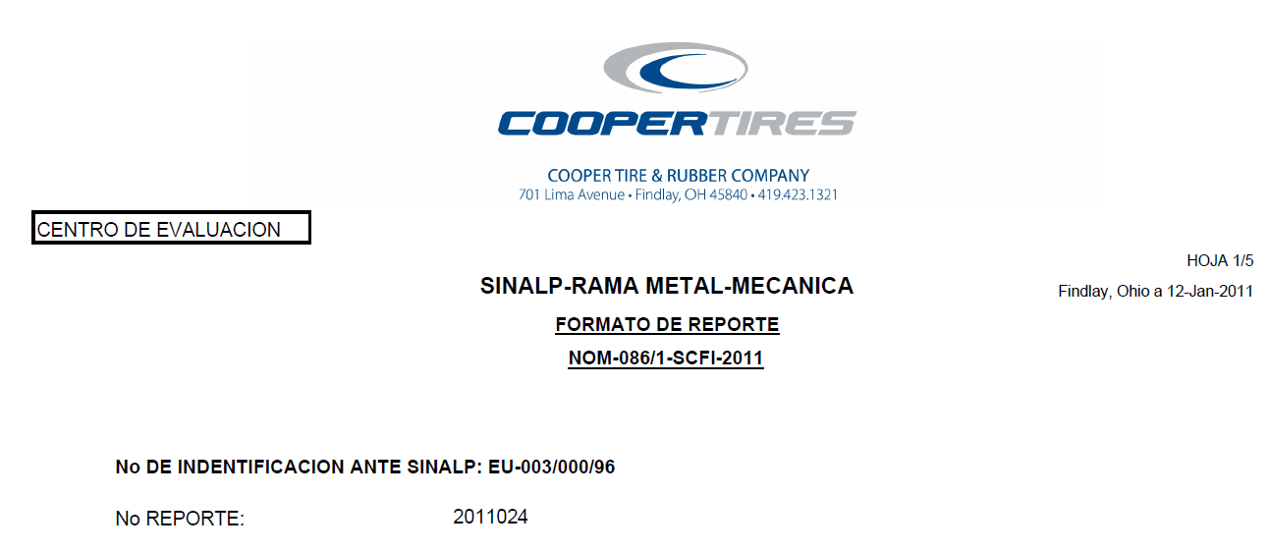

Select a report, enter the Material Number, select the Certificate Type, select the Brand and click on Load button.

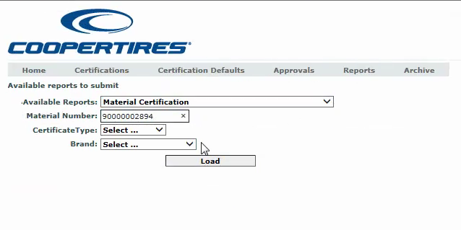

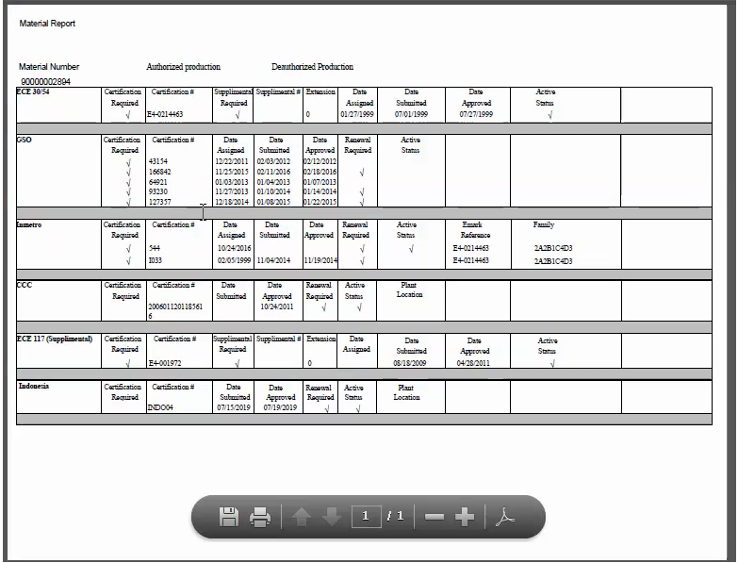

## Archive

When the certificate is no longer valid or expired but are stored in the history for reference are maintained in Archive. Enter the certificate no and click on Archive button.

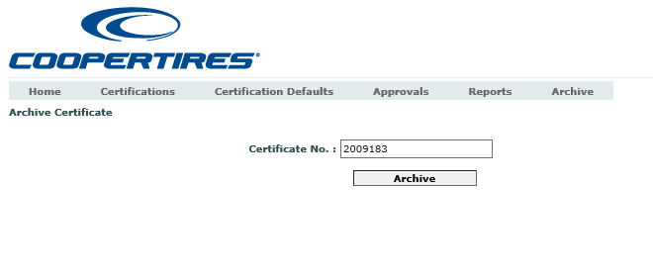

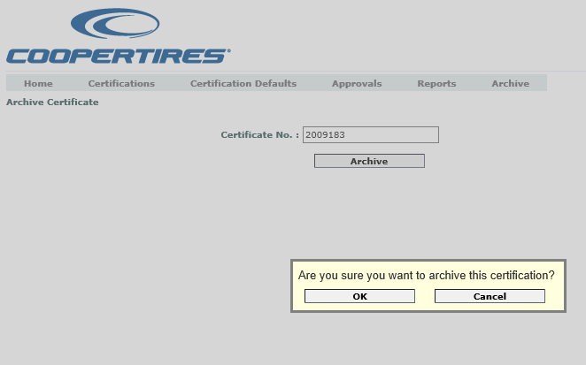

By clicking on Ok button the certificate will be Archived.

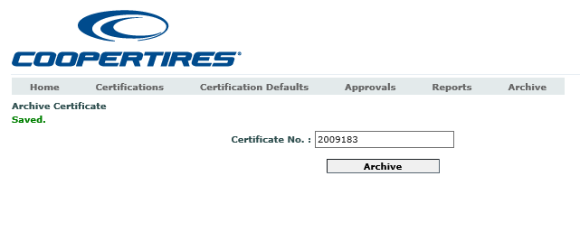

## Approvals

All Pending requests are displayed in the grid in Approvals page. We can select the Pending request and click on Approve Selected button.

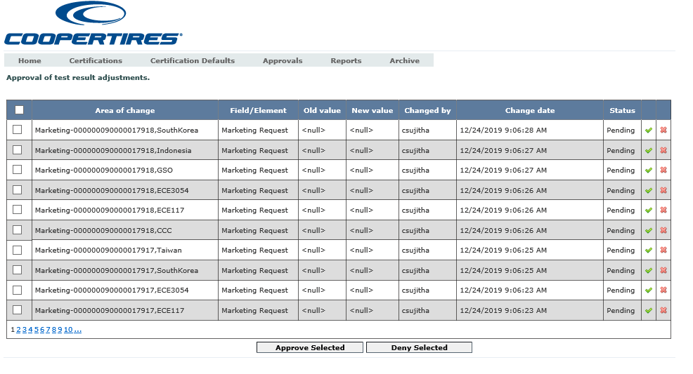

After clicking on Approve selected button the status will get changed from Pending to Approved.

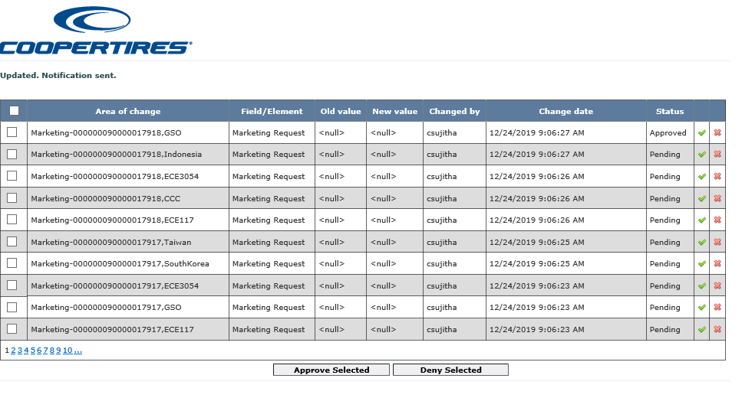

By clicking on Deny Selected button for the selected request the status will get changed from Pending to Deny.

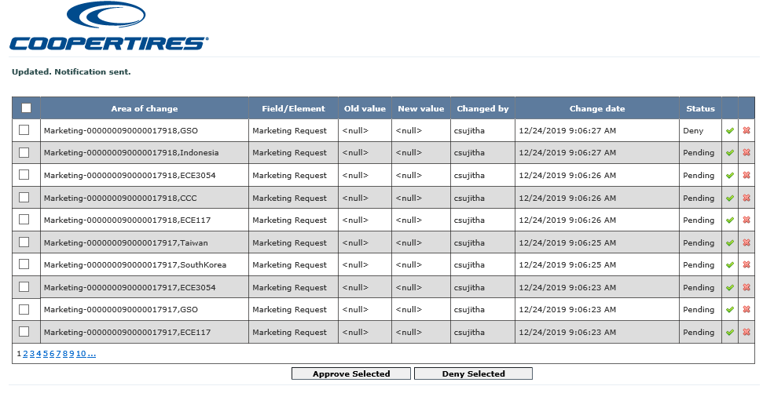

# Database

## Database details

Different databases exist for each of the environments as listed below and each are identified with their own SID name.

* Development
* QA
* Production

## Database Object references (TNS Details)

* Production – TECHNICAL
* QA – TECH_QA
* Dev – TECH10

# External Interfaces

There are no external interfaces for this application.

# Background jobs

Every night a job runs and generates a flat file and another job that reads the flat file and places in SAP.

# AD Groups

Active Directory (AD) Groups are used to define the access allowed by individual users and Industrial PC’s (IPC) The Active Directory Group is responsible for maintaining the entries in the Active Directory Database. Requests for additions to the AD Groups need to be assigned to the Active Directory Group.

## AD Group Member Entries for Individual User

Individual users are granted access to the application by having their login profile added to an AD Group.

* **Application**
* ICS
* **AD groups** associated are:

APP_ICS_MKT

APP_ICS_QS_EMP

APP_ICS_QS_MGR

# Document history

|  |  |  |  |
| --- | --- | --- | --- |
| Version | Date | Author | Reason |
| 1.0 | 08/27/2019 | Fahad Naseer |  |
| 1.1 | 02/06/2020 | Jhansi |  |